Manila Water Company
Technical specification – ENHAMCEMENT
MWC_DID_M2C_169
Validation of Duplicate


Contents
1 Document Organization 4
1.1 Document Log 4
1.2 Integration, Document Reference 4
2 Program Attributes 5
2.1 Authorization Requirements 6
2.1.1 Definition 6
2.1.2 Defined Fields 7
2.1.3 Procedure 7
2.2 Technical Flow Diagram 7
2.3 Processing Logic 7
2.4 Error handling 7
2.5 BRF Details 7
2.6 Fiori Extension 7
2.7 Cloud Extension 7
2.8 Custom DDIC Objects 8
2.9 Custom Business Object Details 8
2.10 Custom CDS Views Details 8
2.11 Custom Field details 8
2.12 Custom Logic/Enhancement Details 9
2.13 Custom Reusable Elements (Code-list, Library) 9
2.14 Form & Email Extensibility 9
2.15 Messages 10
2.16 Subroutines 10
3 Assumptions in Technical Design 10
4 Open Issues in Technical Design 10
5 Unit Test Results 10
6 Related Documentation 11

Document Organization
This section provides details about this document, previous version(s) of this document and the document(s) referred.

Document Log
Following table mentions the version changes and the processer(s):
Version | Status | Date | Version Created by (Name/E-Mail/Company) | Role | Comments
1 | Draft | March 18, 2025 | Sayyad Sarfraz Ali | Author

Integration, Document Reference
S. No. | Referred Document Name | Referred Document Version | Referred Document URL (Optional)

Program Attributes

Enhancement Object
BADI | ORDER_SAVE
METHOD | CHECK_BEFORE_SAVE

Message Class | ZORDER_SAVE

SAP Tables Read | CRMS4D_SERV_H

Authorization Requirements
N/A

Definition
Implements logic in BADI ORDER_SAVE - CHECK_BEFORE_SAVE to prevent duplicate service requests in SAP

Defined Fields

Procedure
1. Define Data Types
- The enhancement defines several data types (ty_guid, ty_pdate, and ty_sold) to handle GUIDs, posting dates, and partner information.
- These are structured types used in internal tables to store request-related data.
2. Retrieve Service Request Details
- If IV_GUID is not empty, it means a service request exists.
- The GUID is stored in lt_h_guid and used to fetch relevant CRM order data.
3. Fetch CRM Order Data from SAP Tables
- The function module CRM_ORDER_READ is called to retrieve order-related details.
- Data is extracted from the following SAP tables:
  - CRMS4D_SERV_H (Service Request Header)
  - CRMT_PARTNER_EXTERNAL_WRKT (Partner Details)
  - CRMT_ORDERADM_H_WRKT (Order Administration Details)
- Key retrieved fields:
  - POSTING_DATE (Service request date)
  - CHKLST_ID (Checklist ID for the service request)
  - SOLD_TO_PARTY (Customer who raised the request)
4. Validate Against Existing Entries
- A date range is calculated by subtracting 7 days from the current POSTING_DATE.
- The system checks if another request exists within this 7-day window:
- The CRMS4D_SERV_H table is queried using the date range to check for duplicate entries.
5. Check for Duplicate Service Requests
- If another entry exists with the same SOLD_TO_PARTY, CHKLST_ID, and an active status (STAT_LIFECYCLE <> 'C'), the system raises an error.
6. Exception Handling
- If a duplicate is found, the system triggers an error message (Type 'E') using a custom message class ZORDER_SAVE.
- If no duplicate is found, the system allows the request to proceed.

Technical Flow Diagram
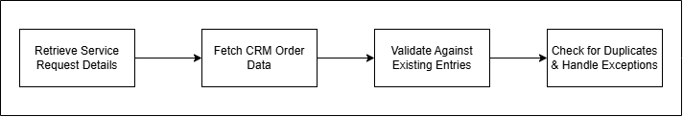

Processing Logic

STEP 1 : Open the SAP Fiori Launchpad and click on the "Service Processing Service"
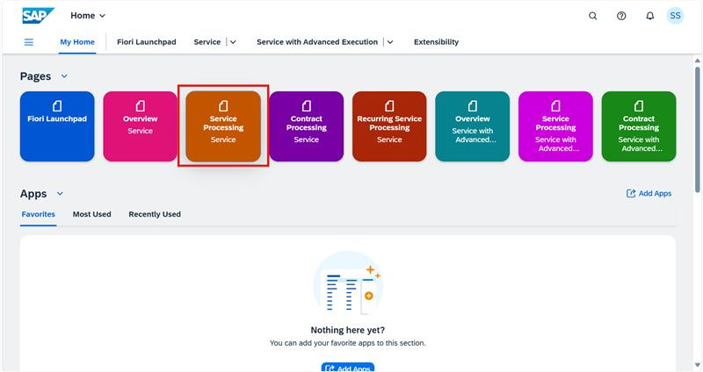

STEP 2 : Click on the "Manage Service Requests" tile to view existing requests.
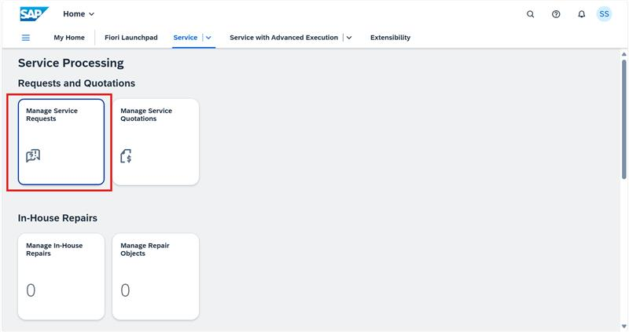
STEP 3 : Select the service request.
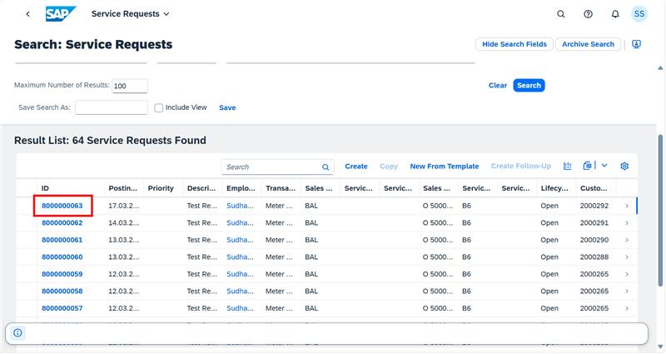
STEP 4 : Open the request and click on the "Copy" button to create a duplicate
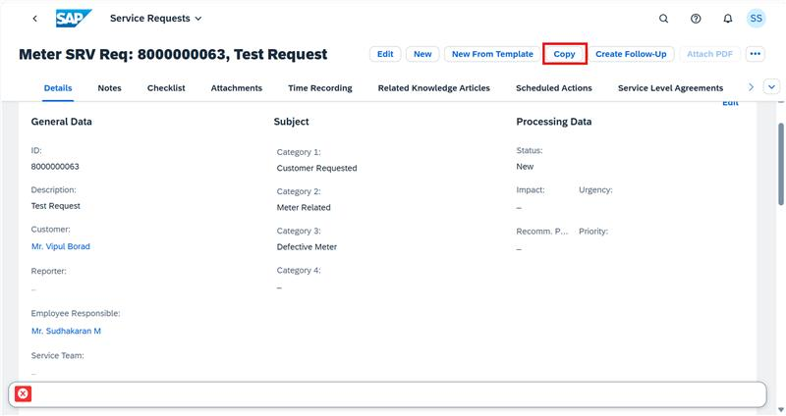
STEP 5 : Update the necessary details in the copied request and click "Save".
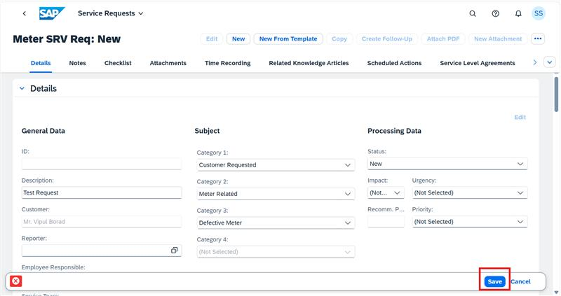
STEP 6 : If a duplicate exists, the system prevents saving and displays an error message.
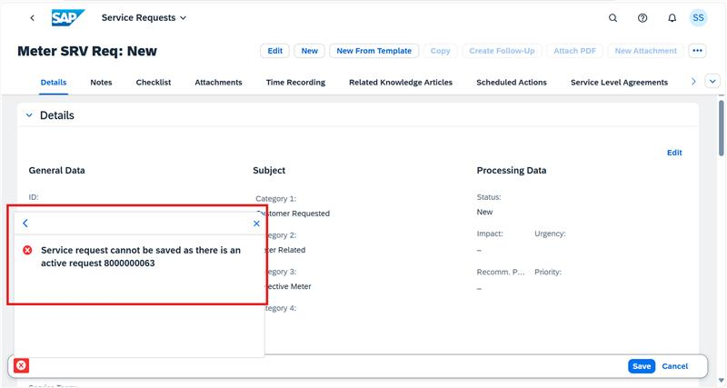

Error handling
If a duplicate request is found within the 7-day window, an error message is raised, preventing the request from being saved.

BRF Details
N/A

Fiori Extension
N/A

Cloud Extension
N/A

Custom DDIC Objects
N/A

Custom Business Object Details

Custom Business Object Name
Field Name | Type | Length

Custom CDS Views Details

Custom CDS View Name
Primary View
Associated Views

Custom Field details

Custom Logic/Enhancement Details

Enhancement Name
Logic

Custom Reusable Elements (Code-list, Library)

Custom Code list
Used in

Form & Email Extensibility

Form Templates
Email Templates
Data Source Details

Messages
Message Class | Message ID | Message Text

Subroutines
Name | Description

Assumptions in Technical Design

Open Issues in Technical Design

Unit Test Results
Scenario # | Input Selection Criteria | Expected Result | Actual Test Pass/Fail
 |  |  | Choose an item.
 |  |  | Choose an item.
 |  |  | Choose an item.

Related Documentation

Template Version
Version | Status | Date | Version Created by (Name/E-Mail/Company) | Role | Comments
1.0 | Final | February 11, 2019 | Abhishek Nayak | Author
1.1 | Final | March 15, 2022 | Abhishek Nayak | Author | Updated to include In-App Extension artifacts like Custom logic, Custom Fields, Custom BO, Custom CDS Views, Custom Code list, Libraries, Form & Email Extensibility.

